Data Downloading (to computer)

It is possible to output data within JOB files to the computer in JOB unit.

(1) Set parameters.
Select “4. Comms setup” in Config Menu.

Config
- Obs. Condition
- Instr. Const
- Date&time
- Comms setup
- Unit
- Key function
- System

Press ENTER key, the “Comms setup” screen is displayed. Set all the items as following:
Comms setup
Baud rate : 115200b/s
Data bits : 8bits
Parity : None
Stop bit : 1bit
Check sum : No
Xon/Xoff : Yes

Start up the communication software in computer. Press Comm, then press Parameter.
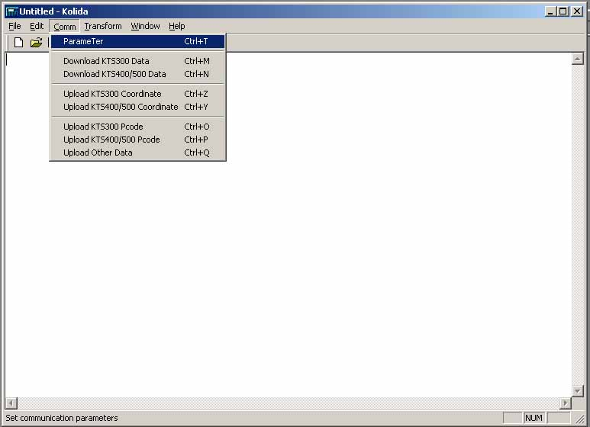
Set items as below, all the setting must be same with total station.
Note: PROTOCOL must be set to Ack/Nak.
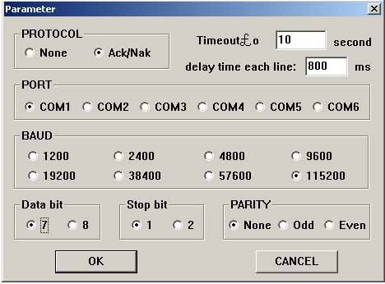
(2) Data transfer
When setting is finished, click Download Kts400/500 Data under the Comm menu, below screen is displayed.
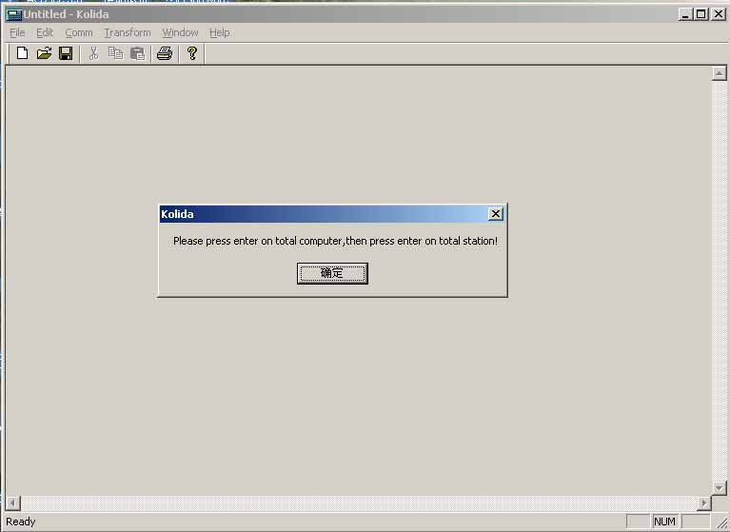

⑴ Select “1. JOB” on the “Memory Mode Menu Screen” and press ENT (or press numeric key 1), the “JOB Management Screen” is displayed.

Memory
1. JOB
2. Known data
3. Code
Mem./JOB
1. JOB selection
2. JOB deletion
3. Comms output

⑵ Select “3. Comms output” and press ENT (or press numeric key 3), the “JOB Management Screen” is displayed.
The “JOB Selection Screen” is displayed.
··Move item: ▲or▼
Comms output
* JOB01 20
* JOB02 8
JOB03 10
JOB04 0
JOB05 0
JOB06 0
-P TOP LAST
·Changing the cursor motion unit: -P
·When –P is displayed, the cursor moves from line to line.
·When -P is displayed, the cursor moves from page to page.
·Display top of JOB name: TOP
·Display end of JOB name: LAST

⑶ Select the job name to be output and press Enter key on the keyboard of computer then press ENT on total station to start output. Following screen will be showed.

Comms output

Format：SDR33
Job：JOB01
Sending 20

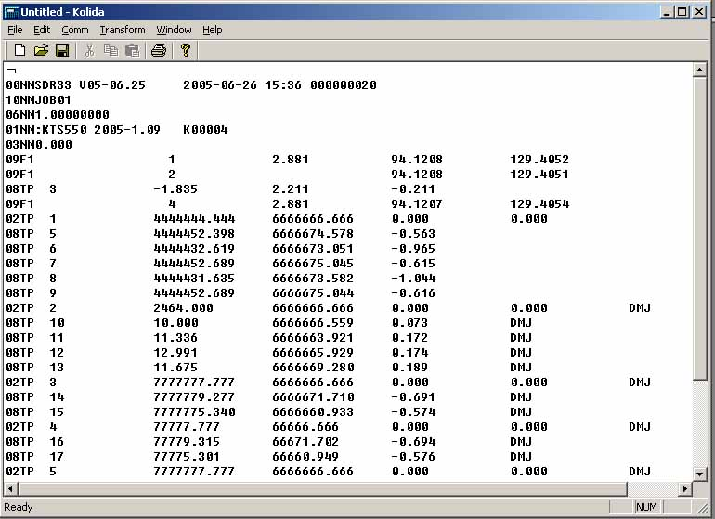

⑷ When output is completed, the “Output JOB Selection Screen” is restored. It is possible to select and output another job.

Comms output
JOB01 20
* JOB02 8
JOB03 10
JOB04 0
JOB05 0
JOB06 0
-P TOP LAST

After transfer, select Save as in File menu to save the downloaded data. See below.
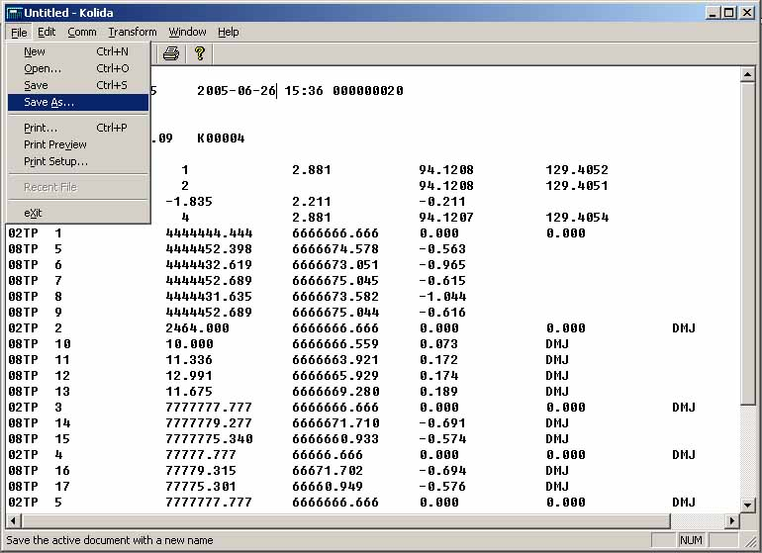

Please save it and give me the file.

Data Uploading (To total station)

For example, to upload a JOB file to another total station.
Start up the communication software. Click File, then click Open. Open a JOB file and
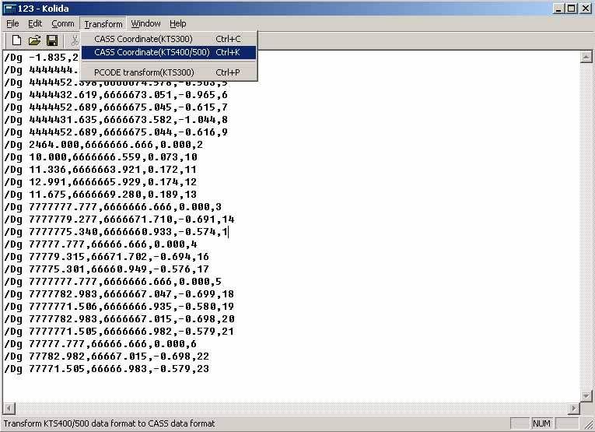

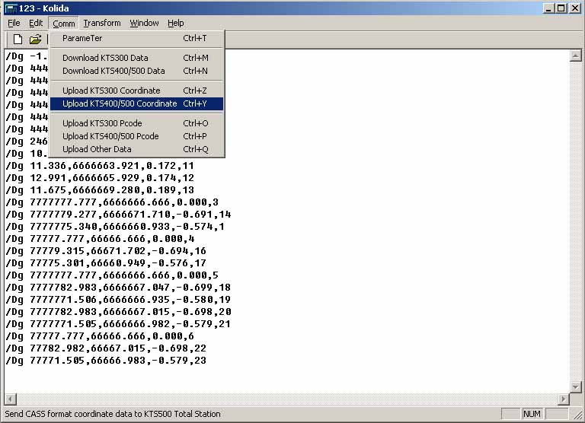

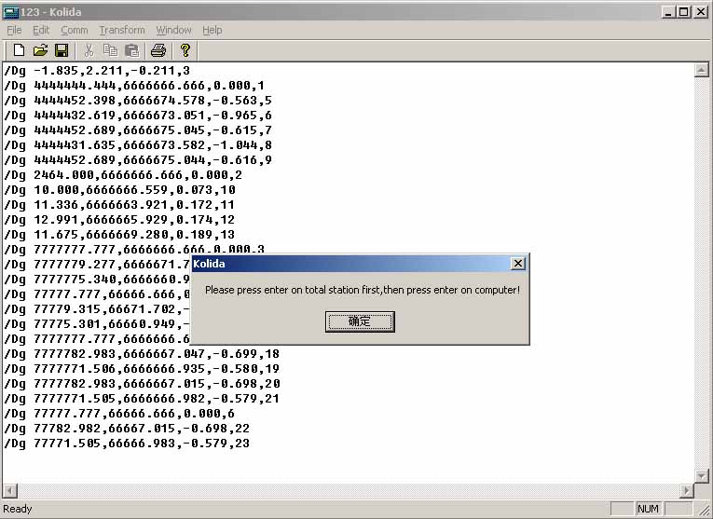

·The format of the coordinate data is the SDR33. There are two formats, see below:
1. /Dg 123.456, -1234.123, 12.345, 1234.678[,SUM]CRLF
a b c d e
- Data idenfication code
- N coordinate
- E coordinate
- Z coordinate
2. The coordinate format which is provided by KOLIDA software.
Point number，，E，N，Z CRLF

·The communication conditions conform to the set communication conditions represented by parameters.（Refer to “23.1Changing Instrument Parameters”）

Operating Procedure | Operation | Display
⑴ Select “2. Known data” in the “Memory Mode Screen” and press ENT to show the “Known Point Menu Screen”. | “2. Known data”  +  ENT
  Mem./ Known
  1. Key in coord
  2. Comms input
  3. Deletion
  4. View
  5. Clear
⑵ Select “2. Comms input” and press ENT, the “Data Format Display Screen” is displayed. Press ENT again, start data reception. The received data amount is showed on the bottom of the screen. | ENT  +  ENT
  Mem./ Known
  Format. SDR33
  Receiving 25
☆ Note：Before performing communication between KTS and other equipments, make sure that their communication parameters should be equal.（Refer to “23.1 Changing Instrument Parameters”）

