Work file (JOB) Uploading (to total stations)
Please make sure that the software of 550 has been updated to be Ver06.01.10
It is possible to input data within JOB files to the computer in JOB unit.

(1) Set parameters.
Select “4. Comms setup” in Config Menu.

Config
- Obs. Condition
- Instr. Const
- Date&time
- Comms setup
- Unit
- Key function
- System

Press ENTER key, the “Comms setup” screen is displayed. Set all the items as following:
Comms setup
Baud rate : 1200b/s
Data bits : 8bits
Parity : None
Stop bit : 1bit
Check sum : No
Xon/Xoff : Yes

Start up the communication software in computer. Press Comm, then press Parameter.
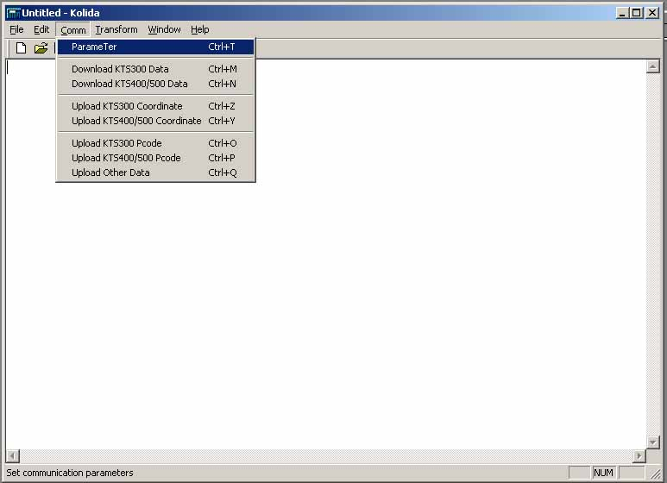
Set items as below, all the setting must be same with total station.
Note: PROTOCOL must be set to Ack/Nak.
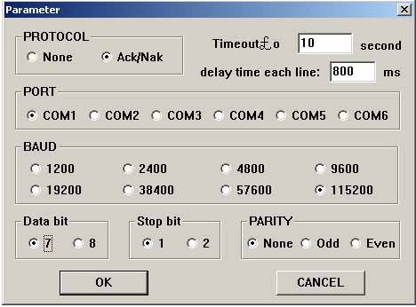
(2) Data transfer

Open your JOB file in communication software.
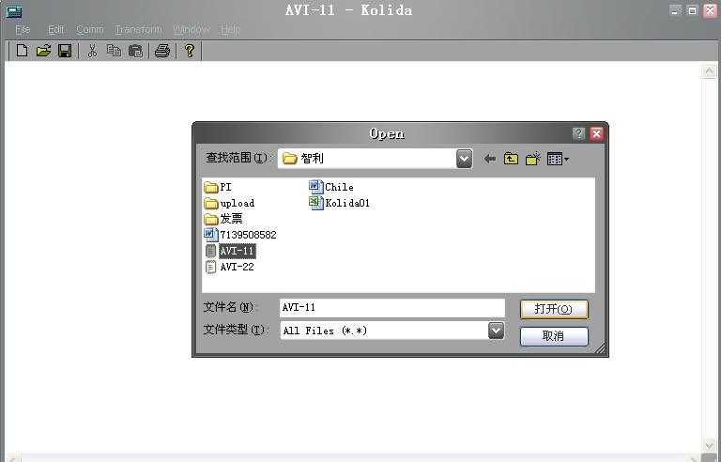

Please ensure your data are in right format.
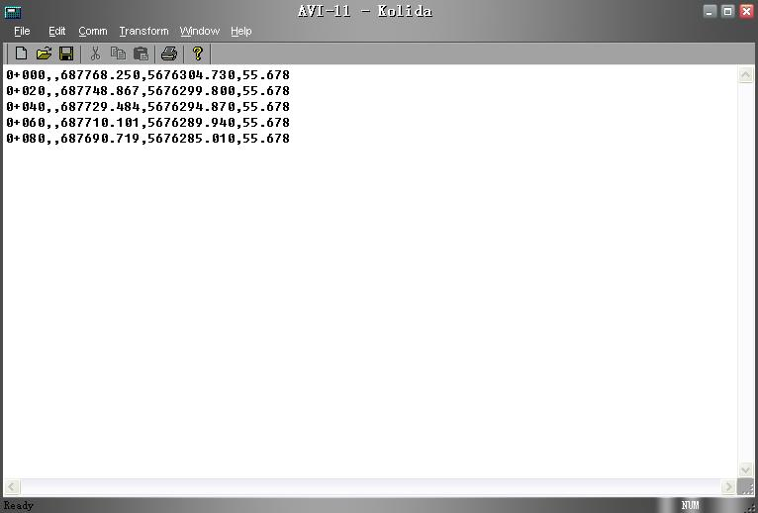
Select Upload KTS-400/500 coordinate
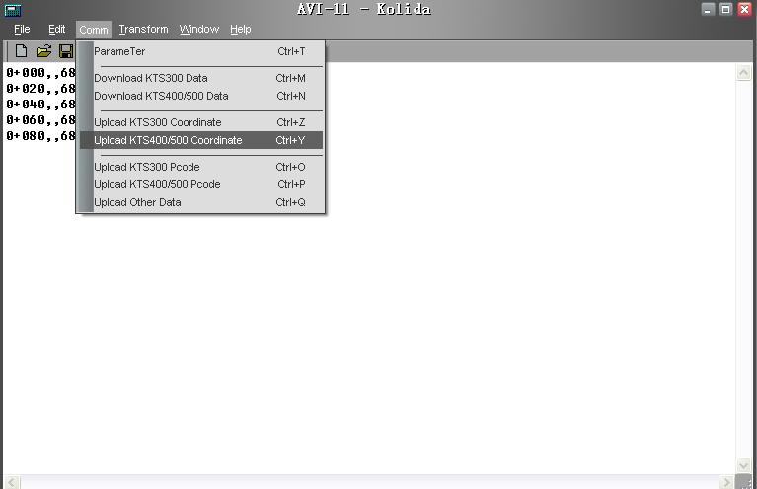
Below screen will be shown.
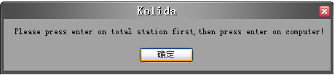
NOW WE OPERATE TOTAL STATION AS BELOW,
⑴ Select “1. JOB” on the “Memory Mode Menu Screen” and press ENT (or press numeric key 1), the “JOB Management Screen” is displayed.

Memory
1. JOB
2. Known data
3. Code
Mem./JOB
1. JOB selection
2. JOB deletion
3. Comms output
4. Comms Input
5. JOB key in Coord

⑵ Select “4. Comms input” and press ENT (or press numeric key 4), the “JOB Management Screen” is displayed.
The “JOB Selection Screen” is displayed.
··Move item: ▲or▼
Comms output
* JOB01 0
* JOB02 0
JOB03 0
JOB04 0
JOB05 0
JOB06 0
-P TOP LAST
·Changing the cursor motion unit: -P
·When –P is displayed, the cursor moves from line to line.
·When -P is displayed, the cursor moves from page to page.
·Display top of JOB name: TOP
·Display end of JOB name: LAST

⑶ Select the job name to be input and press Enter key on the keyboard of total station then press ENTER on computer to start output. Following screens will be showed.

Comms input

Format：SDR33
Job：JOB01
Receiving 5

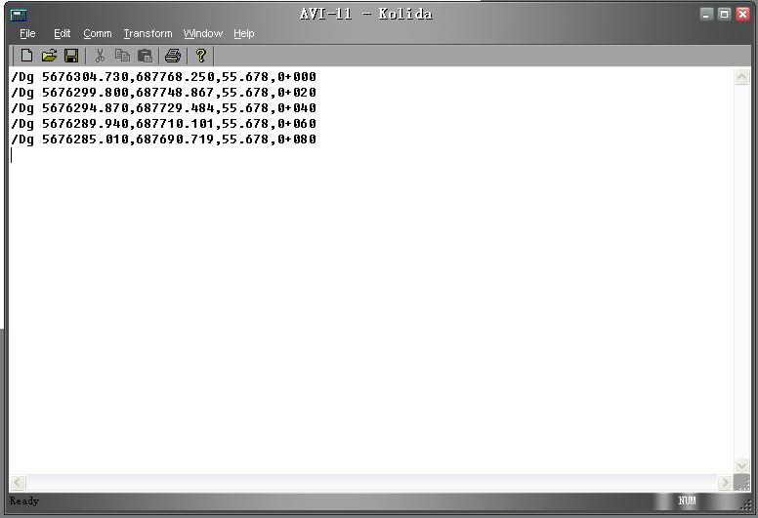

⑷ When input completed, the “Output JOB Selection Screen” is restored. It is possible to select and input another job.

Comms output
JOB01 5
* JOB02 7
JOB03 0
JOB04 0
JOB05 0
JOB06 0
-P TOP LAST

