Instruction of the driver installation for digital level

Please check the operating system of the PC firstly when carrying out data transmission by USB, if the operating system is Windows 2000/xp/2003 server/vista, select to install the driver program “CP210x_VCP_Win2K_XP_S2K3.exe”, if the operating system is windows 7, please install “CP210x_VCP_Win7.exe”.
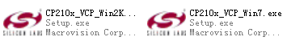
Now for example: installing “CP210x_VCP_Win2K_XP_S2K3.exe”
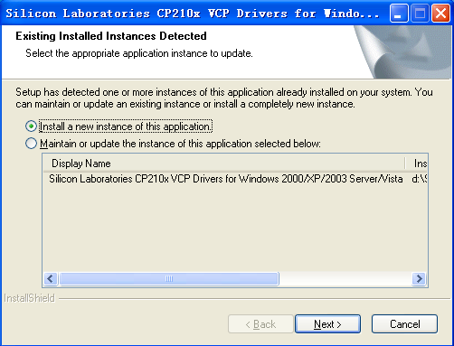
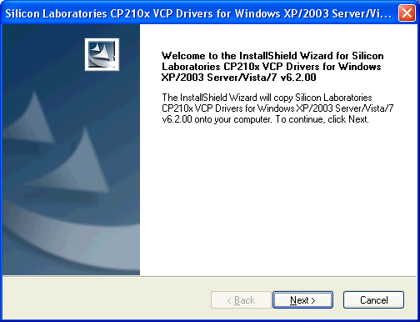
click Next
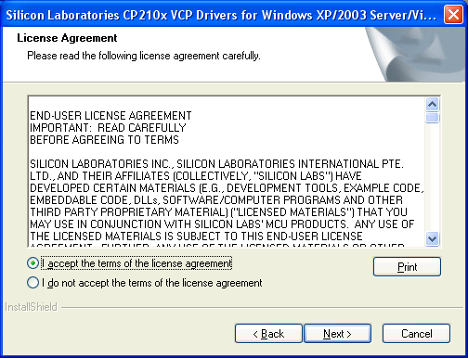
click Next
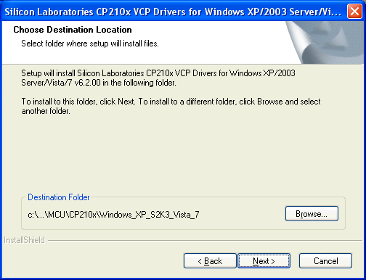
Click Browse，select the installing path
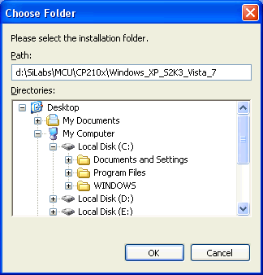
Click ok
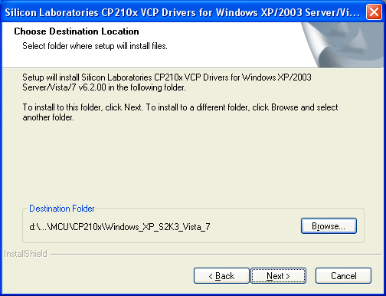
Click Next
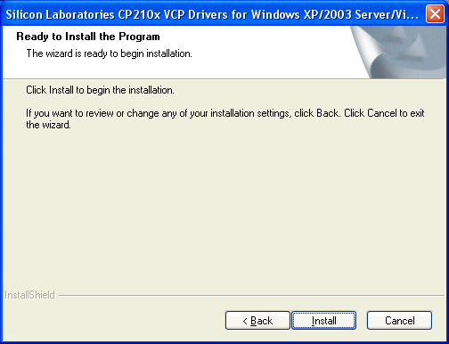
Click install
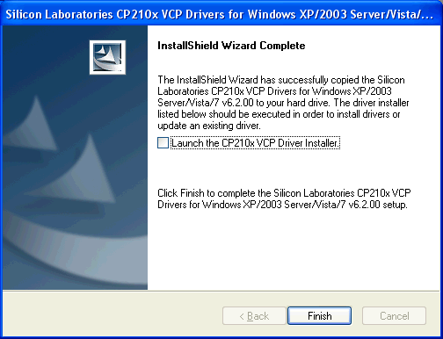
Click “finish” to finish the installing，the position is at “ D:\SiLabs\MCU\CP210x\Windows_2K_XP_S2K3_Vista\”
Connect the PC and the digital level by the USB cable, press the power on key on the digital level, now the computer will find the new hardware and install automatically ；

then click “my computer” using the right mouse button, then click “property”
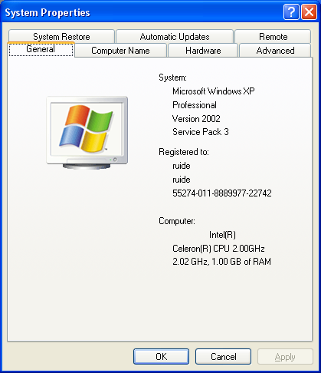
click “hardware”
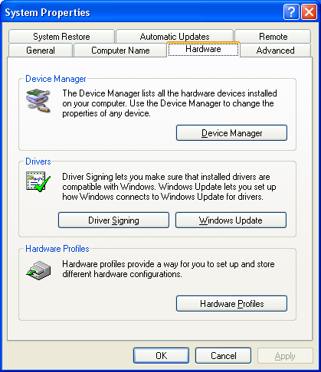
click device manager and then click port
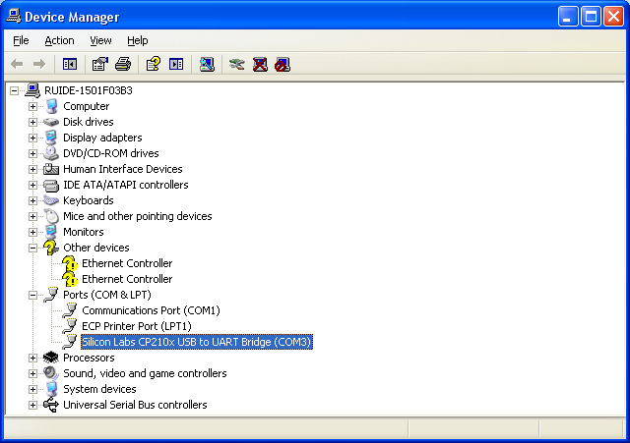
Review the position of the port that “Silicon Labs CP210x USB to UART Bridge ” be in(example COM3), then exit

